ASPIRING LEADER (AL) 110 – VALUES, ETHICS, MORALS & LEGAL



Course Schedule
Session | Duration | Activity Description
Introduction & Icebreaker | 15 minutes | Introduce yourself
Introduction & Icebreaker | 15 minutes | Icebreaker Activity
ELO 1 – Define Personal Core Values | 20 minutes | Facilitated Discussion: Define personal core values.
ELO 1 – Define Personal Core Values | 15 minutes | Practical Application: Group Activity
ELO 1 – Define Personal Core Values | 5 minutes | Check on Learning: Short quiz
BREAK
ELO 2 – Apply Criteria to Critical Decisions | 20 minutes | Facilitated Discussion: Apply criteria to ethical decisions.
ELO 2 – Apply Criteria to Critical Decisions | 15 minutes | Practical Application: Group Activity
ELO 2 – Apply Criteria to Critical Decisions | 5 minutes | Check on Learning: Short quiz
BREAK
ELO 3 – Analyze Kohlberg’s Six Stages of Moral Development | 20 minutes | Facilitated Discussion: Apply Kohlberg’s 6 Stages of Moral Development.
ELO 3 – Analyze Kohlberg’s Six Stages of Moral Development | 15 minutes | Practical Application: Group Activity
ELO 3 – Analyze Kohlberg’s Six Stages of Moral Development | 5 minutes | Check on Learning: Short quiz
BREAK
ELO 4 – Nature of Workplace Regulations and Legalities | 20 minutes | Facilitated discussion: Examine the nature of workplace regulations and legalities.
 | 15 minutes | Practical Application: Group Activity
 | 5 minutes | Check on Learning: Short quiz
BREAK
Course Evaluation | 5 minutes | Provide feedback on the course
End of Course Exam | 10 minutes | 20 course exams
Final Thoughts and Wrap Up | 15 minutes | Key Takeaways and Reflection Moment

 |  | Notes:
 |  | Notes
 |  | Notes:

 |  | Notes:
 |  | Notes
 |  | Notes:

 |  | Notes:
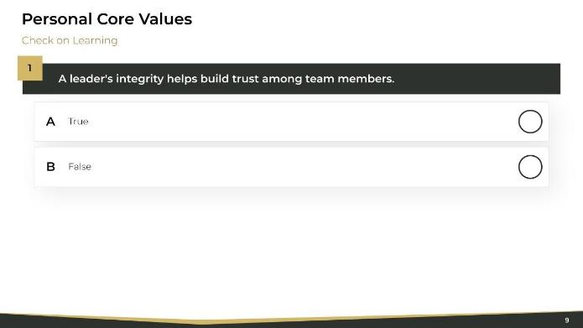 |  | Notes
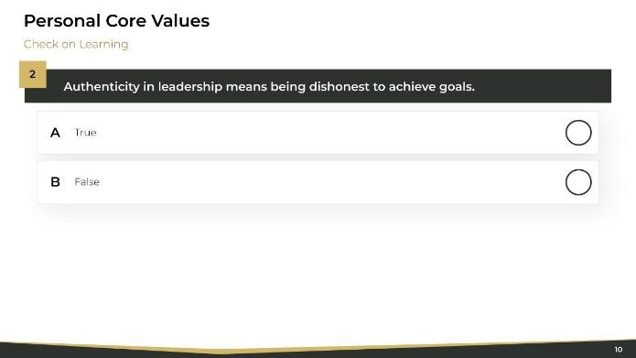 |  | Notes:

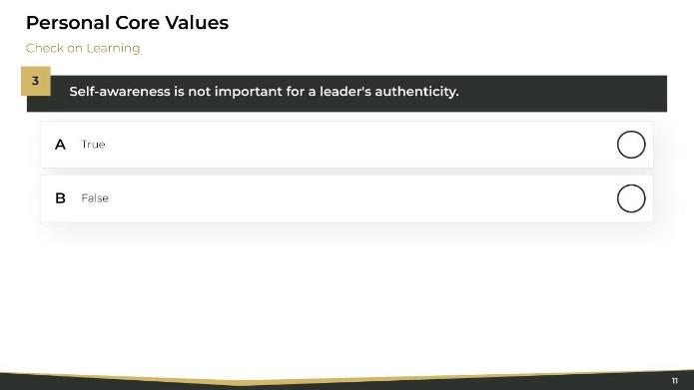 |  | Notes:
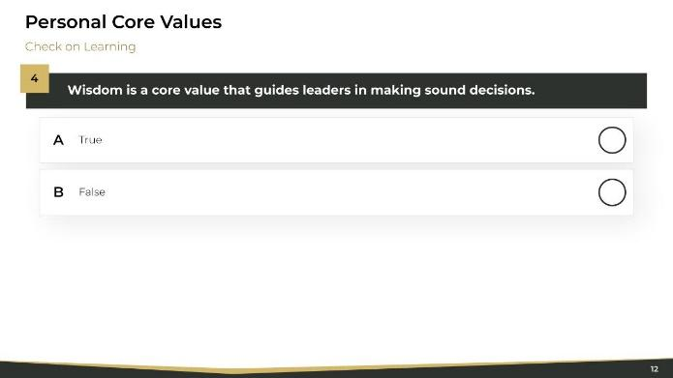 |  | Notes
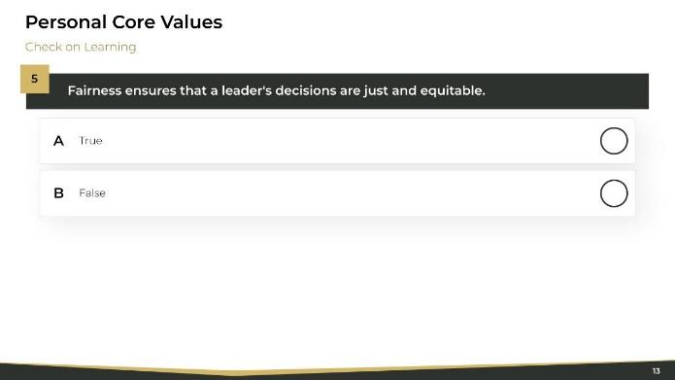 |  | Notes:

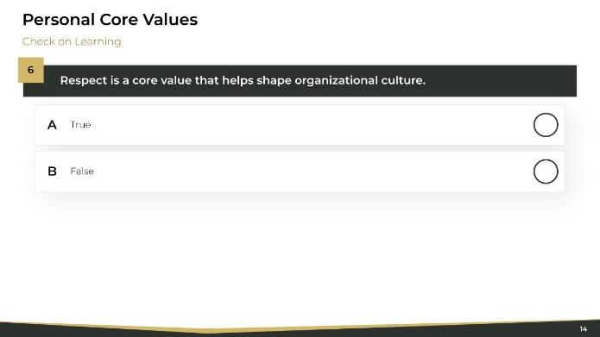 |  | Notes:
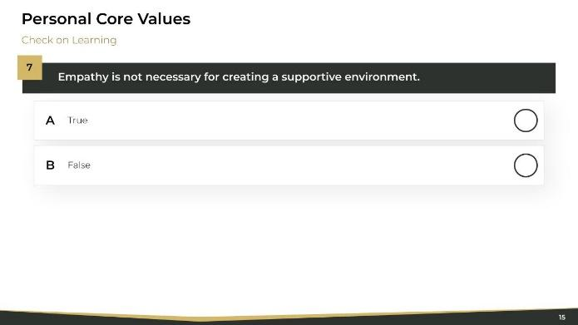 |  | Notes
 |  | Notes:

 |  | Notes:
 |  | Notes
 |  | Notes:

 |  | Notes:
 |  | Notes
 |  | Notes:

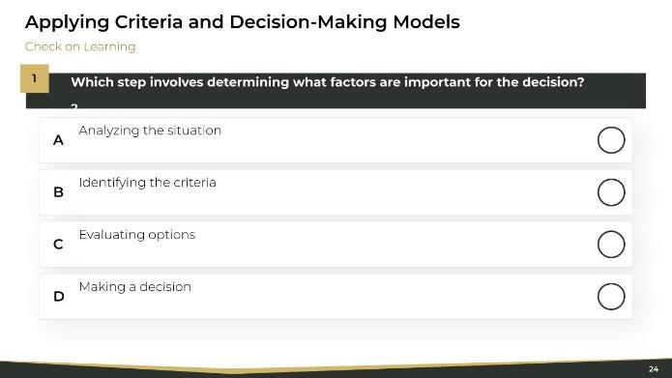 |  | Notes:
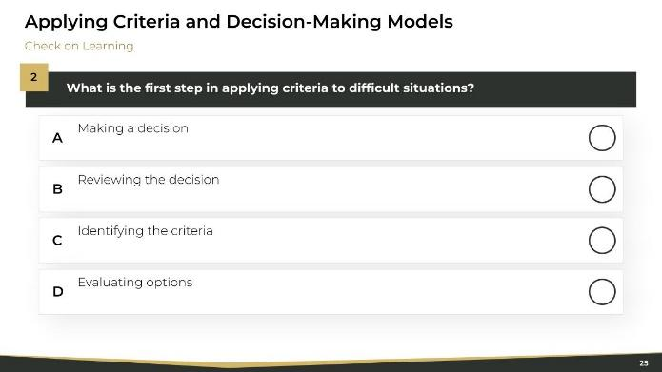 |  | Notes
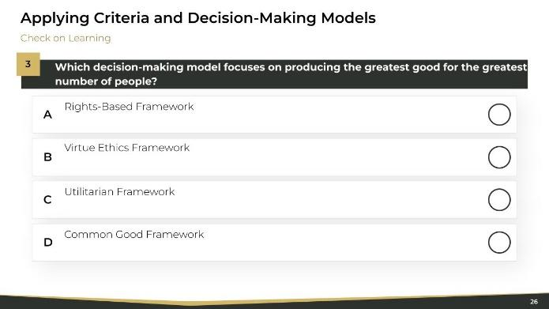 |  | Notes:

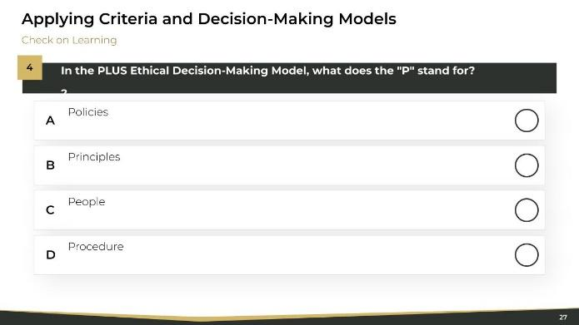 |  | Notes:
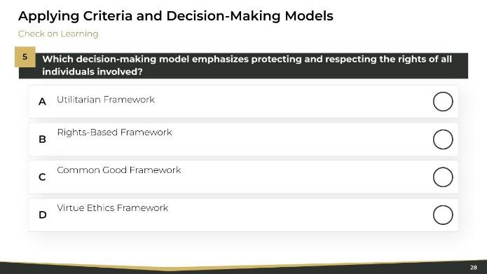 |  | Notes
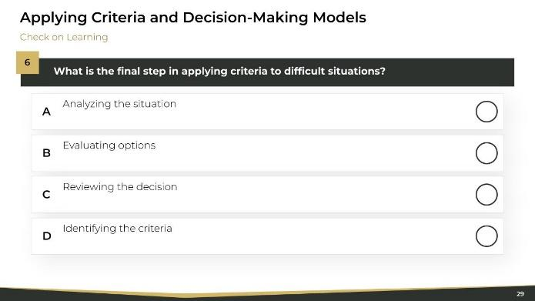 |  | Notes:

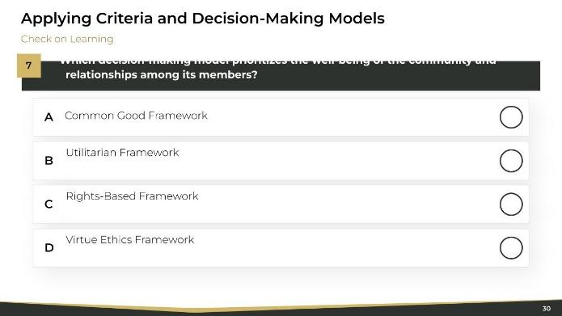 |  | Notes:
 |  | Notes
 |  | Notes:

 |  | Notes:
 |  | Notes
 |  | Notes:

 |  | Notes:
 |  | Notes
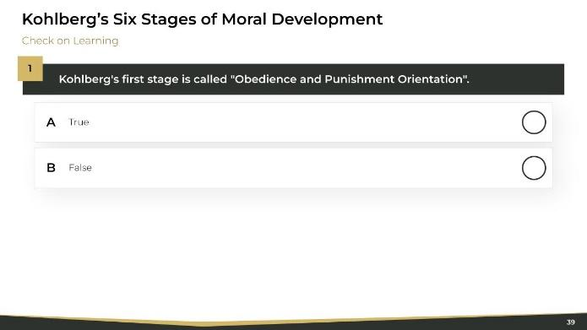 |  | Notes:

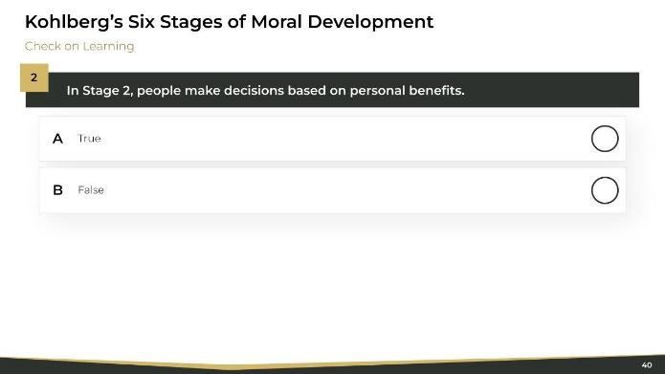 |  | Notes:
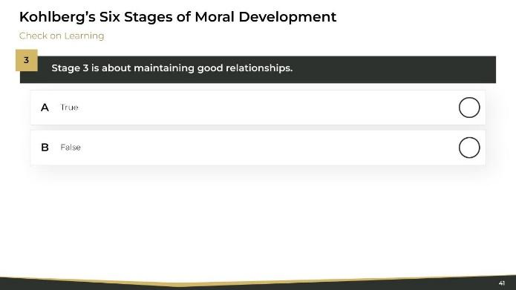 |  | Notes
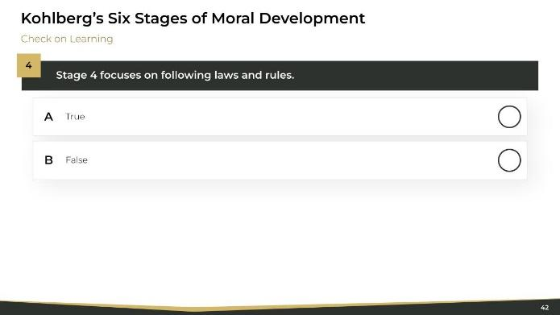 |  | Notes:

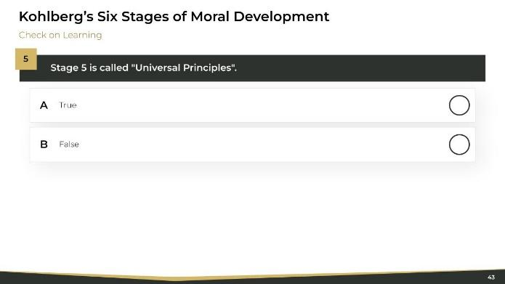 |  | Notes:
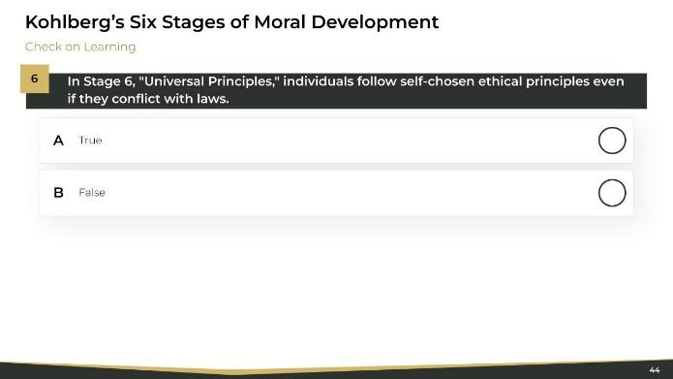 |  | Notes
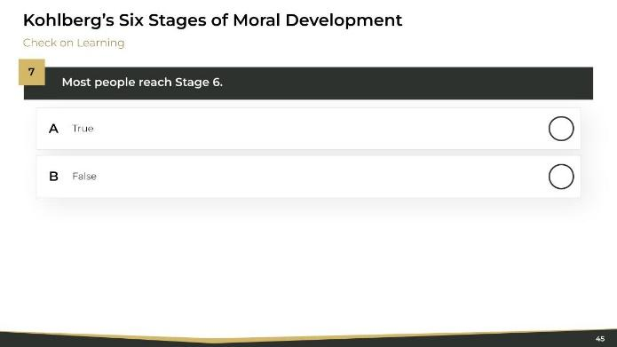 |  | Notes:

 |  | Notes:
 |  | Notes
 |  | Notes:

 |  | Notes:
 |  | Notes
 |  | Notes:

 |  | Notes:
 |  | Notes
 |  | Notes:

 |  | Notes:
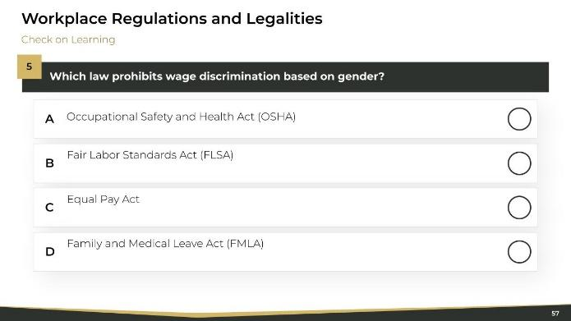 |  | Notes
 |  | Notes:

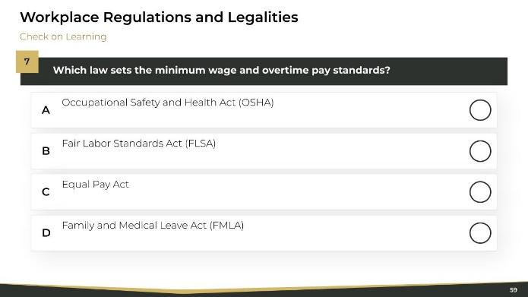 |  | Notes:

